Sprint 3 - Agility Design Document

December 6, 2021

Use this Requirements Specification template to document the requirements for your product or service, including priority and approval (Must do).

This document will also serve as a System Design Document (How to) and will include sections detailing system flow, algorithms, staffing plan, software/hardware, and Test Plan

This document contains instructions and examples which are for the benefit of the person writing the document and should be removed before the document is finalized.

To regenerate the TOC, select all (CTL-A) and press F9.

Table of Contents

1. Executive Summary 3

1.1 Project Overview 3

1.2 Purpose and Scope of this Specification 3

2. Product/Service Description 3

2.1 Product Context 3

2.2 User Characteristics 3

2.3 Assumptions 4

2.4 Constraints 4

2.5 Dependencies 4

3. Requirements 4

3.1 Functional Requirements 4

3.2 Security 5

3.2.1 Protection 5

3.2.2 Authorization and Authentication 5

3.3 Portability 5

4. Requirements Confirmation/Stakeholder sign-off 5

5. System Design 5

5.1 Algorithm 5

5.2 System Flow 6

5.3 Software 6

5.4 Hardware 7

5.5 Test Plan 7

5.6 Task List/Gantt Chart 9

5.7 Staffing Plan 9

# Executive Summary

## Project Overview

## The basis of this project is for the students to properly engage in and work on block code to further operate a Sphero robot. The students will all work together in finding out how to solve the agility portion of the Robotics Project and get the robot to follow the intended specifications. At the end of the project the students have developed skills that will enabled them complete the Robotics project.

## Purpose and Scope of this Specification

In scope

The purpose of this project is to create an application that will enable the Sphero SPRK+ to move along the obstacle course track. This application will give students a final more in-depth view on how to program the Sphero SPRK+. Being the last of the robot projects this will sum up the entire robotics project and give students a final look at how to block code a robot.

Out of Scope

This application is part three of three in the robotics project being the last in the project. This application, being the third out of the two, will give students a final in-depth view on how to program the Sphero Robot. This application will also be harder as the students must be able to complete the specified program and obstacle course.

# Product/Service Description

## Product Context

This program will relate to the other programs necessary to complete the Robotics Triathlon. This program is independent for Sprint 3 but will join two other independent programs to complete all the tasks in the Triathlon. It is interfaced with phones and computers. The diagram below shows how the Sprints are all independent yet interconnected by the Triathlon.

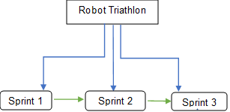

## User Characteristics

* Some of the people that may be using this product include:

Students

Teacher / Professor

Sphero technician

People that have experience using Sphero and block code

Classmates who are comparing codes

## Assumptions

* User has access to a Sphero SPRK+.
* User has downloaded and access to the Sphero application.
* User has access to classroom for robot testing
* User has access to computer to work on Gantt chart and SDD
* User has access to stay after class to work on the project
* User uses time wisely to finish project on time

## Constraints

* Must have enough computer space to store and run the program
* Must be programmed in Sphero
* A device that lacks Bluetooth capability
* Not enough space to effectively test and execute programs
* Group must be able to organize meetings after class time
* Must complete all required documents

## Dependencies

* This new product will require the SPRK+ to follow the obstacle course track around the classroom
* The robot must complete all listed requirements
* Groups must be able to effectively communicate
* The group must be able to meet to go over the project and discuss what needs to be completed
* The group must come together in order to solve the problem and figure out how to get the robot to follow the correct code to follow the track around the classroom.

# Requirements

## Functional Requirements

| Req# | Requirement | Comments | Priority | Date Rvwd | SME Reviewed / Approved |
| --- | --- | --- | --- | --- | --- |
| AGILIT_01 | Robot will start in the beginning of the marked track | High priority that it must start in the required position because this will alter the rest of the program. | 10/10 | 12/01/21 | Approved |
| AGILIT_02 | Start Robot program in square on floor | Important because this is the first item mentioned in the Agility program | 9/10 | 12/01/21 | Approved |
| AGILIT_03 | Along next robot code, robot must follow track avoiding the 3 objects that are in the track | Highly important as if these objects are not avoided the code must be changed | 10/10 | 12/01/21 | Approved |
| AGILIT_04 | Robot must increase or decrease speed in order to jump the ramp in the next part of the obstacle course | Important because this is another item that is highlighted. The robot must be able to make it over the ramp and land in an appropriate place. | 10/10 | 12/01/21 | Approved |
| AGILIT_05 | The last part of the robot obstacle course requires the robot to go in a straight line and hit the (pins) that are located on the floor like a bowling ball | This is another important aspect as it is the last part of the obstacle course and another feature that is required in the program. | 10/10 | 12/01/21 | Approved |
| AGILIT_06 | Robot must end its program in the correct place | Important because this labels the end of the code for the agility program code | 10/10 | 12/01/21 | Approved |
|  |  |  |  |  |  |
|  |  |  |  |  |  |
|  |  |  |  |  |  |

## Security

### Protection

* Program is password protected by group members devices

### Authorization and Authentication

* Program is privately shared by group members and validated in person.

## Portability

* This project is highly portable because:
* The use of laptops and phones to write and run code enables work to be done basically anywhere
* The application and code are accessible and executable across multiple operating systems
* No internet access is necessary to complete this project
* The SPRK+ is highly portable due to its size
* SPRK+ could be run in almost any indoor environment

# Requirements Confirmation/Stakeholder sign-off

Include documentation of the approval or confirmation of the requirements here. For example:

|  |  |  |
| --- | --- | --- |
| Meeting Date | Attendees (name and role) | Comments |
| 12/01/2021 | Julia and Jolie | Confirmed all |
| 12/02/2021 | Julia and Jolie | Confirmed all |

# System Design

This section will provide all details concerning the technical design, staffing, coding, and testing the system

## Algorithm

Develop and describe here the algorithm that will be used to provide the required performance of your software

1. Have SPRK+ move forward at 0 degrees with a speed of 61 for 1.55 seconds.
2. Delay SPRK+ for 1 second.
3. Have SPRK+ roll 90 degrees at a speed of 61 for 1.8 seconds.
4. Delay SPRK+ for 1 second
5. Have SPRK+ roll 0 degrees at a speed of 61 for 2.2 seconds.
6. Delay SPRK+ for 2 seconds
7. Have SPRK+ roll at an angle of 94 degrees for 2.4 seconds at an increased speed of 131.
8. Delay SPRK+ for 1.5 seconds
9. Have SPRK+ roll at an angle of 224 degrees for 6 seconds at a reduced speed of 81, so that it knocks over the markers.
10. Stop SPRK+.

## System Flow

## 

## Software

Our robot was programmed in Sphero using block code. Below is an image of our sprint 3 block code program along with the sensory data collected after executing the program. The software platform that was used to develop this robotic application was Sphero. This is an online application which enables users to use block code to test out how the robot follows the track around the classroom. This user-friendly program allows the users to simply drag and drop block code and test the code in a less complicated way in comparison to other programming languages. The Sphero application enables the user to understand the basics of programming easily while accomplishing whatever task is at hand. For example, we were able to change the color of the SPRK+’s light by simply using a color wheel; however, if we used a different programming language, we might have had to spend more time trying to figure out the hexadecimal value for the color we needed to use.

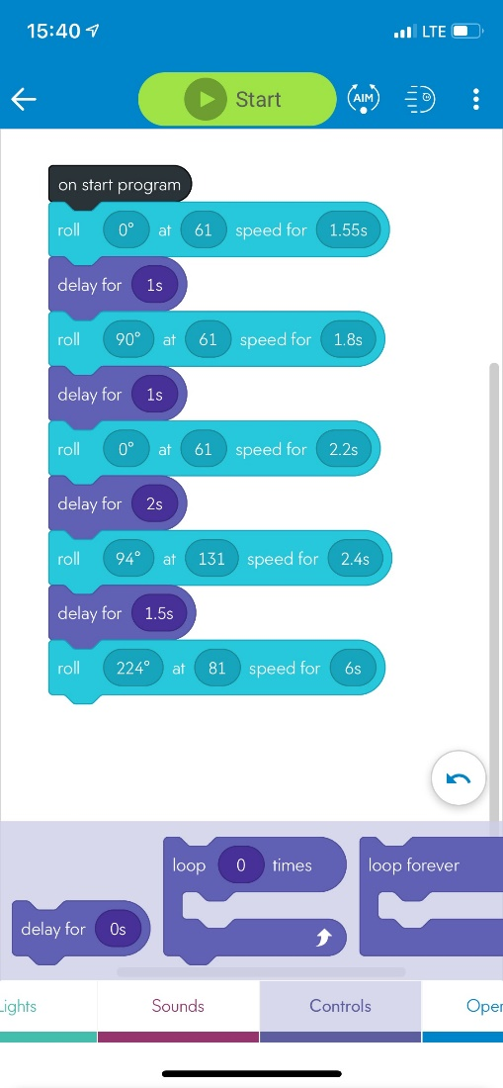

## Hardware

The hardware that we used to undergo this Robotics project was our cell phones or computers. The hardware makes the software an easy-to-use application and helps with the overall programming of the block code. We found that using the computer to code was easier to navigate, but using the phone allowed a more accurate aiming of the SPRK+ because we could move the dial used to aim more precisely. The computer program made this project successful with developing, testing and finalizing the code. We used Sphero SPRK+ to execute our code. We used a cellphone to record the robot video during our demonstration.

## Test Plan

Include a test plan showing all unit tests performed for this application, Include test rational, test date, staff member, pass/fail status

| **Reason for Test Case** | **Test Date** | **Expected Output** | **Observed Output** | **Staff Name** | **Pass/Fail** |
| --- | --- | --- | --- | --- | --- |
| Have SPRK+ go forward on the line of the first straight and then stop before the next line. | 12/01/21 | The SPRK+ will stay on the tape line, will not hit the bottle, and will stop at the end of the line. | The SPRK+ went too far so that it was no longer on the tape line. | Julia and Jolie | Fail |
| Have SPRK+ go forward on the line of the first straight and then stop before the next line. | 12/01/21 | The SPRK+ will stay on the tape line, will not hit the bottle, and will stop at the end of the line. | The SPRK+ moved straight forward on the tape line and then stopped at the edge of the line. | Julia and Jolie | Pass |
| Have SPRK+ rotate 90 degrees and go straight on the second tape line then stop at the end of the straight. | 12/01/21 | The SPRK+ will stay on the tape line, will not hit the bottle, and will stop at the end of the line. | The SPRK+ moved straight forward on the second portion of the tape line and then stopped at the end of it. | Julia and Jolie | Pass |
| Have SPRK+ rotate 90 degrees and go roll forward on the third straight and then stop at the end of it. | 12/01/21 | The SPRK+ will stay on the tape line, will not hit the bottle, and will stop at the end of the line. | The SPRK+ rolled straight on the line, but it went too far and stopped so that it was no longer on the tape line. | Julia and Jolie | Fail |
| Have SPRK+ rotate 90 degrees and go roll forward on the third straight and then stop at the end of it. | 12/01/21 | The SPRK+ will stay on the tape line, will not hit the bottle, and will stop at the end of the line. | The SPRK+ rolled straight on the line and then stopped at the end of it. | Julia and Jolie | Pass |
| Have SPRK+ rotate so that it travels on the fourth straight of the course, travel over the binder, and then stop at the corner. | 12/02/21 | SPRK+ will rotate so that it travels straight on the line of the tape and then will roll up the binder and then land on the ground and stop at the corner of the line. | The SPRK+ did not rotate enough and rolled passed the binder. | Julia and Jolie | Fail |
| Have SPRK+ rotate so that it travels on the fourth straight of the course, travel over the binder, and then stop at the corner. | 12/02/21 | SPRK+ will rotate so that it travels straight on the line of the tape and then will roll up the binder and then land on the ground and stop at the corner of the line. | The SPRK+ rotated enough to start rolling up the center of the binder, but only was able to roll halfway up the binder. | Julia and Jolie | Fail |
| Have SPRK+ rotate so that it travels on the fourth straight of the course, travel over the binder, and then stop at the corner. | 12/02/21 | SPRK+ will rotate so that it travels straight on the line of the tape and then will roll up the binder and then land on the ground and stop at the corner of the line. | The SPRK+ traveled on the tape line and went over the binder, but it rolled too far so it passed the corner of the lines. | Julia and Jolie | Fail |
| Have SPRK+ rotate so that it travels on the fourth straight of the course, travel over the binder, and then stop at the corner. | 12/02/21 | SPRK+ will rotate so that it travels straight on the line of the tape and then will roll up the binder and then land on the ground and stop at the corner of the line. | The SPRK+ traveled on the tape line and went over the binder and then stopped at the end of the line on the corner. | Julia and Jolie | Pass |
| Have the SPRK+ rotate and then go straight on the tape line and knock over the markers. | 12/02/21 | SPRK+ will roll on the tape line, knock over all the markers and then stop. | The SPRK+ rotated too much and then did not roll on the tape line or hit any of the markers. | Julia and Jolie | Fail |
| Have the SPRK+ rotate and then go straight on the tape line and knock over the markers. | 12/02/21 | SPRK+ will roll on the tape line, knock over all the markers and then stop. | The SPRK+ rolled on the tape line and then knocked over all of the markers and then stopped. | Julia and Jolie | Pass |

## Task List/Gantt Chart

\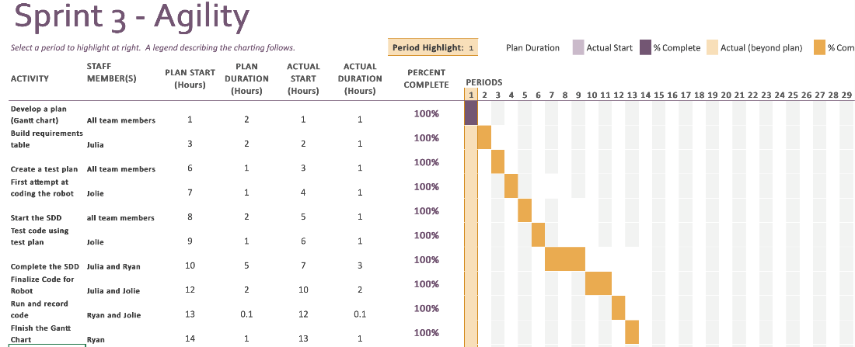

## Staffing Plan

Insert a chart/table that depicts the roles and responsibilities of each team member that worked on this project

| Name | Role | Responsibility | Reports To |
| --- | --- | --- | --- |
| Ryan | Recorder | Organize Gantt Chart, SDD | Julia |
| Jolie | Programmer | Runs block code. Oversees the robot video and flowchart, SDD. | Julia |
| Julia | Leader | Manages GitHub repository, SDD, ensures all parts of the project are completed. | Julia |